Agile Leader Weekly Checklist – Using Jira for Agile Costing
Process Definition
This job aid covers the items an Agile Leader needs to complete on a weekly basis to manage their team.

- Manage Whoville Information
- Ensure Team Roster is Correct
- Ensure Primary Team Field is Checked
- Manage Agile Costing Indicator

- Manage Team Availability
- Review Standard Activities
- Reduce Allocation Hours for Standard Activities

- Monitor Incoming Demand
- Monitor “My Action Items” Tile for Estimate Requests
- Monitor “Assignments Requested” Tile for Approvals

- Manage Team Utilization
- Ensure Team is Not Under/Over Utilized

- Manage Team Work in Jira
- Manage Issue Statues and Assignments

- Manage Whoville Information
Objectives
It is important to ensure that all information about your team is correct in Whoville. It must be managed on a regular basis.

What You Need to Know
The Whoville application is the source of record for team information. This information feeds into Planview Portfolios and is used to group all resources on your team together and for management and for agile costing.
Ensure Team Roster is Correct

Steps:
If you have any resources join or leave your team, you must access Whoville and add or remove them from your team’s roster. You must take into consideration the timing of when the change needs to happen as it takes an overnight feed to populate into Planview Portfolios. For example: if a resource is joining your team on a Monday, you will need to make the change on Friday in Whoville and the update will be available in Planview Portfolios on Monday.

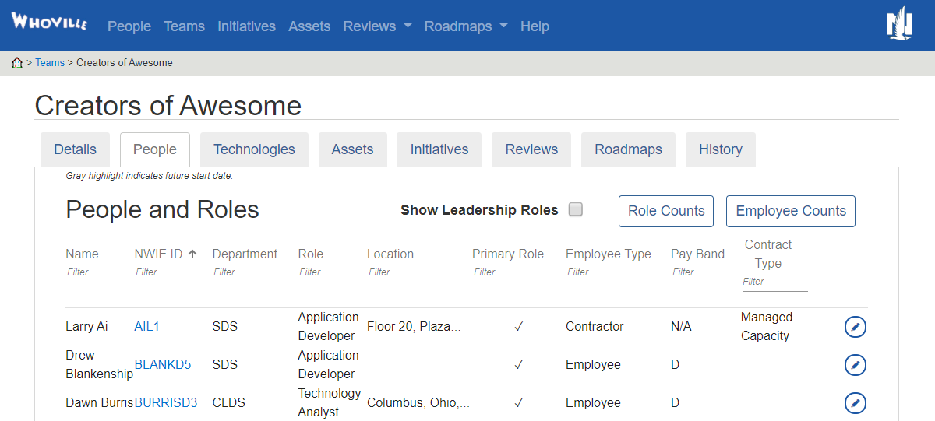

Ensure Primary Team Field is Checked

Steps:
Even though resources can work across multiple teams, they can only be assigned to one team in Planview Portfolios. The Primary Team field in Whoville must be checked for the team that the resource works on the most. You must take into consideration the timing of when the change needs to happen as this also takes an overnight feed to populate into Planview Portfolios.

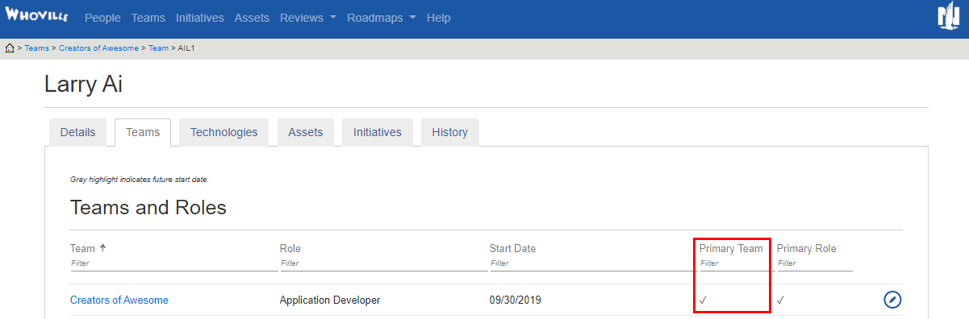

Manage Agile Costing Indicator
The team level Agile Costing indicator refers to whether the team is leveraging agile costing within Planview Portfolios or not. The default for new teams is to be ‘checked’ or ‘on’. The team level indicator setting overrides the individual costing indicator.

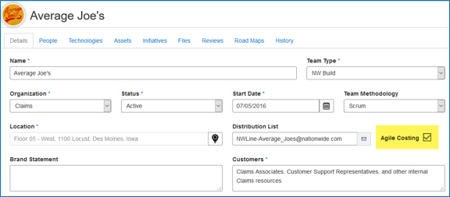

Navigating to the Team – People tab, individuals have a costing indicator (C*) noted with a ‘$’ for if agile costing is ‘on’ for the individual. This can be edited to be turned off for individuals on teams that are individually allocated in Planview Portfolios if needed.

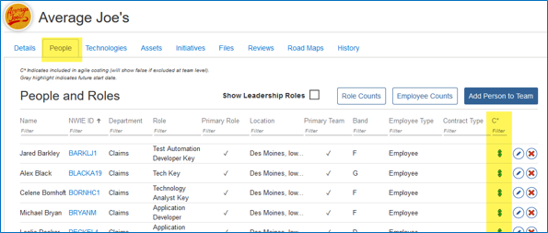
- Manage Team Availability
Objectives
It is important to accurately represent each resource’s available time to support defining project plans with realistic resource schedule information. Because of this, Agile Leaders must ensure that out of office and training standard activities are entered by the appropriate person for each of the resources on their team.
What You Need to Know
Agile Leaders typically use the Staffing (formerly known as Resource Management and Assignments) view for their team to review and enter resources to standard activities as the activities become known.
Out of Office for Associates: Automatically added via Workday integration.

Don’t Forget:
- Workday will override any manual entries of associate out of office standard activities.
- Associates will need to ensure that out of office in Workday is updated as soon as possible to leverage this integration.
- All out of office of four or more hours in Workday will be counted as one full day in Planview Portfolios

Out of Office for “On the Team” Contractors: Manually added by the Agile Leader
Out of Office for “Off the Team” Contractors: Manually added by the Delivery Coordinator/Deliver Leader
Training for Associates: Manually added by Resource Manager
Training for Contractors: Not applicable

Don’t Forget:
- Training lasting more than four hours must be entered. Teaching Thursday, Pluralsight or other training that is less than four hours does NOT need to be entered.
- The offshore contractor calendar does not include holidays as non-working days. Any out of the office time for holidays would need to be manually added as an out of office standard activity for the offshore contractor.

Review Standard Activities
In Planview Portfolios, resources are managed from the Staffing (formerly known as the Resource Management & Assignments) screen.
Process Steps:
- Click the Menu drop-down and select Resources.
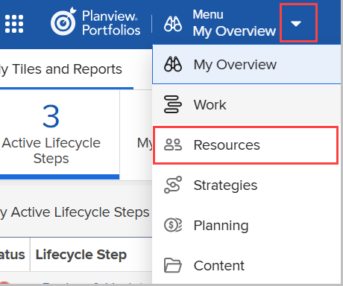

- Click the Sub Menu drop-down and select under the ‘recently viewed portfolios’ section.
Note:
- Sub Menu drop-down lets you select a specific portfolio or work item.
- If the portfolio or work item has been recently viewed, the sub menu will display them.
- If the work item is not displayed in the sub menu, click ‘see all work portfolios’.

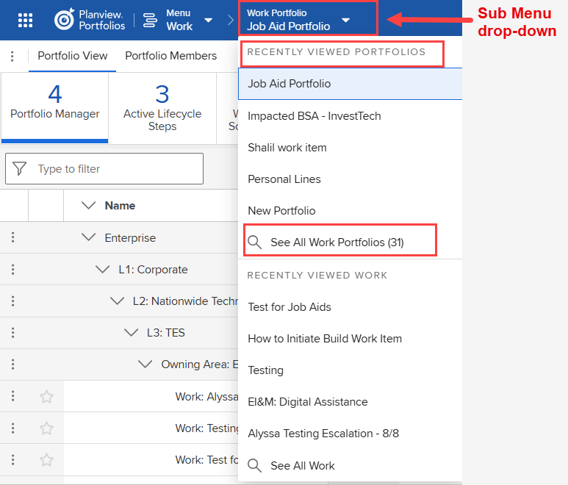
- The Navigation Bar options will display as following. Click on Staffing tab (which was formerly known as the Resource Management & Assignments screen).
- Review future out of office entries for your associates and contractors for issues.
If issues exist:
  - For associates, instruct them to make the update in Workday. Any changes will load the next day.
  - For contractors, contact the Contractor Agile Leader/Delivery Coordinator/Delivery Leader so they can adjust the standard activity.
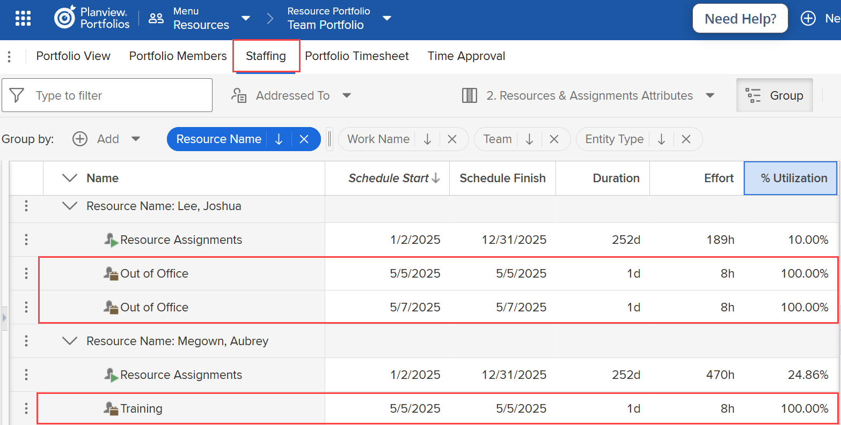
Reduce Allocation Hours for Standard Activities
If you have resources on your team that are individually allocated to work items and are unavailable due to a standard activity, the allocations must be removed. If your team does not have individual allocations, you do not need to complete these steps.

Don’t Forget:
- This is important so the project isn’t charged for work that isn’t being done when the resource isn’t available.

Steps:
- From the Staffing (formerly known as RMA) screen, click on the drop-down next to Month, and select Days. This will allow you to easily remove the hours for the specific days the resource has a standard activity.

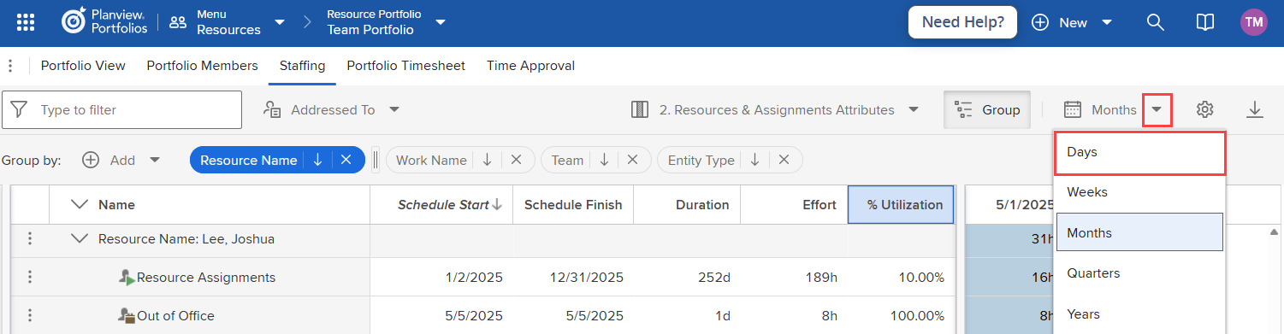

- Click on the Cog Wheel icon, select Gradient Range under Display Resource-Utilization, then Apply.

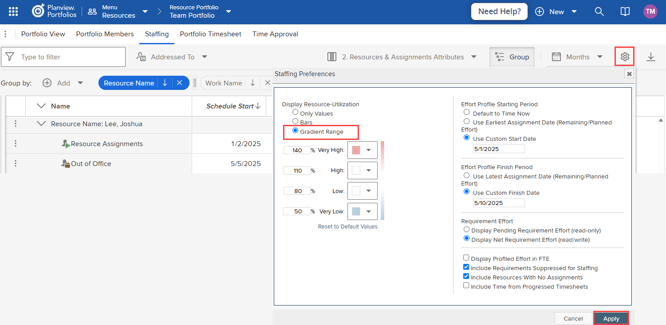

- Using the Gradient Range setting will allow you to quickly see over utilization highlighted in red and where adjustments need to be made.

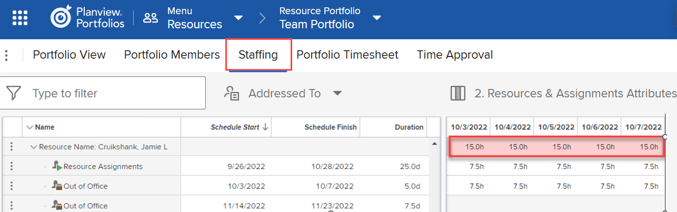
- Click on the field where allocations exist to activate the field and type “0” to remove the hours, you will notice that the red highlight goes away once the allocation is removed.

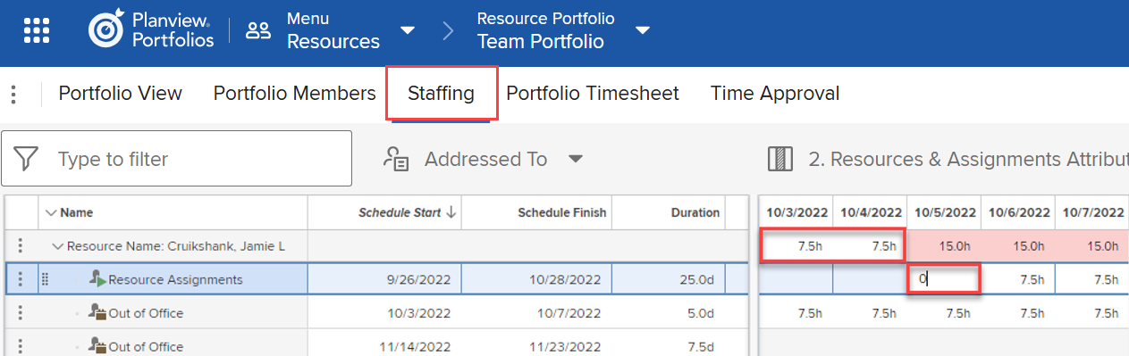
- If a resource has multiple assignments, each of them will need to be removed.

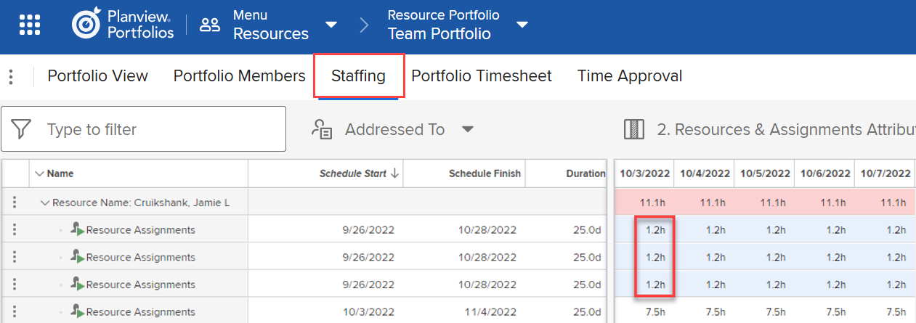

Monitor Incoming Demand
Objectives
- Monitor new requests for estimates.
- Monitor new team reserve requests, adjust hours, and approve for all committed work.
- Monitor new resource requests (if individually allocated), adjust allocations, and approve for all committed work.
What You Need to Know
It is important to monitor incoming demand on a weekly basis to ensure that the team’s demand is in alignment with their capacity.

Monitor “My Action Items” Tile for Estimate Requests
Estimate requests are submitted via action items. The “My Action Items” tile can be added to your My Overview screen so you can monitor when you have been assigned to complete an estimate.

Steps:
- Click on the action's menu next to the action item name, then click Detail.

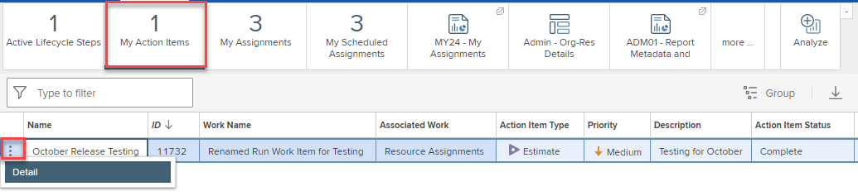

- Enter estimated hours in the Planned Effort field, the Team to be assigned to do the work in the Team field and select Completed from the Action Item Status drop down.

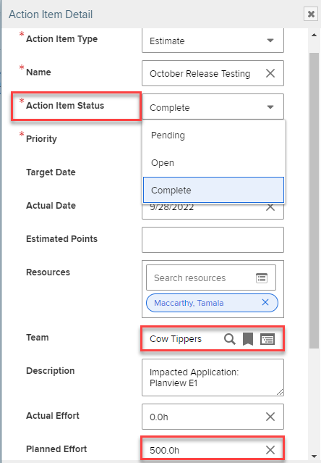

Monitor “Assignments Requested” Tile for Approvals

The “Assignments Requested” tile is located on the Portfolio View of your team portfolio. This tile can help notify you when you need to take action on incoming demand requests. It will display the number of requested reserves that need approved.

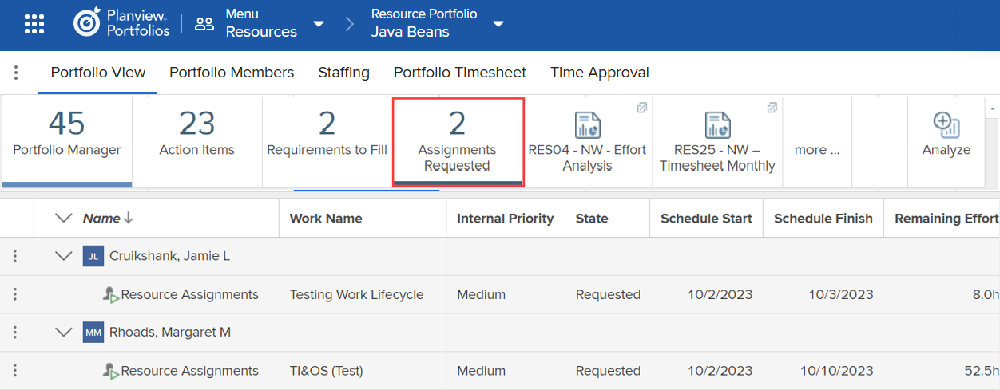

It’s easier to complete the approvals from the Staffing (formerly known as Resource Management and Assignments) screen, so when you see a number on the Assignments Requested tile, click on the Staffing tab on the navigational bar.

Steps:
- Locate the Team Resource and sort the State column by clicking on the heading at the top.
- Verify that the Reserve assignment type was used. The icon should be a purple pushpin.
- If another assignment type is used, reach out to the Work Manager to have this corrected.

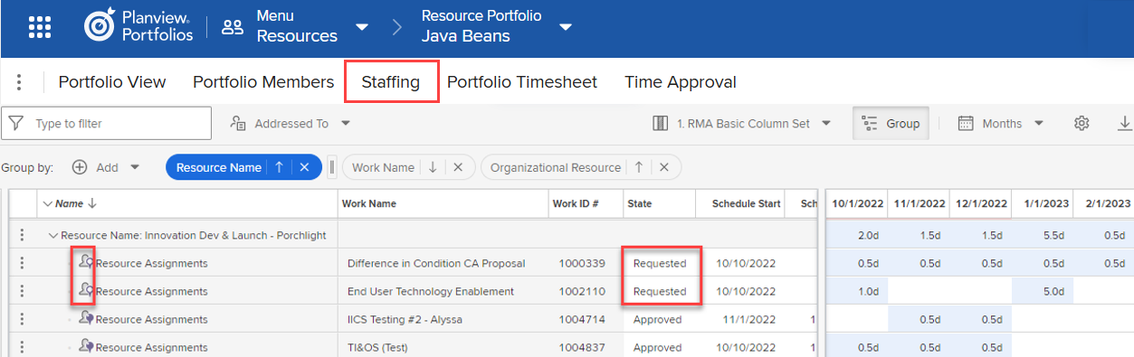

- Requests for your team should not be scheduled to begin within the next 30 days. If you receive a request that begins within the next 30 days, reach out to the Work Manager for details.
- Using the grid at the right, review the reserved hours and adjust as needed.
- Change the State from Requested to Approved to indicate that the demand is committed. Or change the State to Denied if your team cannot commit to the demand.

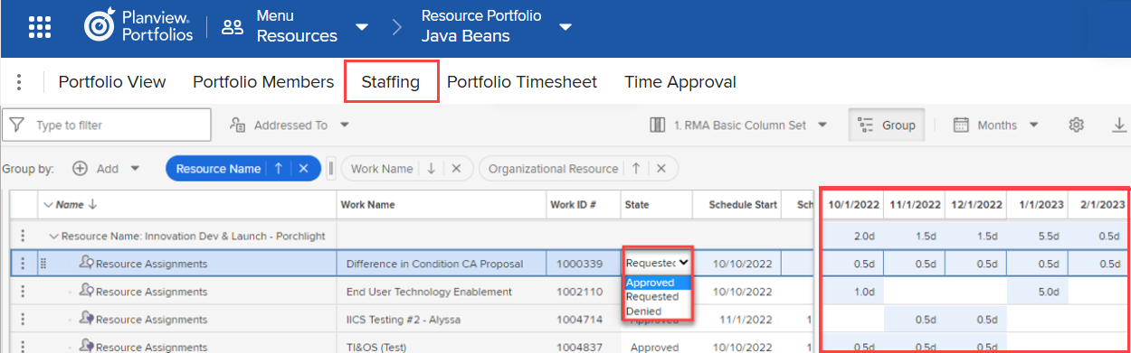
Don’t Forget:
- If you make any changes to the reserve hours on the resource management side, you need to communicate what you have done to the relevant Work Manager.

Manage Team Utilization
Objectives
- Use Staffing (formerly known as Resource Management and Assignments) to review the status of assignments for appropriateness.
- Keep resource workloads balanced.
What You Need to Know
To ensure accurate forecasting of project work, team reserves must be actively monitored. Approval targets should be met as follows: 90% of team capacity approved 30 days prior to the effort start date, 50% approved at 60 days out, and 25% approved at 90 days out. These benchmarks support effective resource planning and alignment with project timelines.
Ensure Team is Not Under/Over Utilized
The NW Custom RES03 report allows you to review the requested and approved demand for your team and compare it to the availability of your team. For details on how to run the NW Custom RES03 report, click here. When adjustments need to be made, this is done via the Staffing (formerly known as Resource Management and Assignments), Resource & Assignments Attributes view from within the team portfolio.
Steps:
- Access the resource portfolio you have created for your team and open the Staffing (formerly known as Resource Management and Assignments) screen.
- Locate the team resource where the reserves are located. Make any necessary adjustments from within the timescale grid on the right. Use the totals at the top to ensure that the numbers are in line with the team’s availability for each week/month.
- Remember, as each week passes, the progressing engine runs and removes the past week’s reserve hours. If the actuals captured were less than what was planned and the additional hours are still needed, you will need to move those hours forward to the next week.
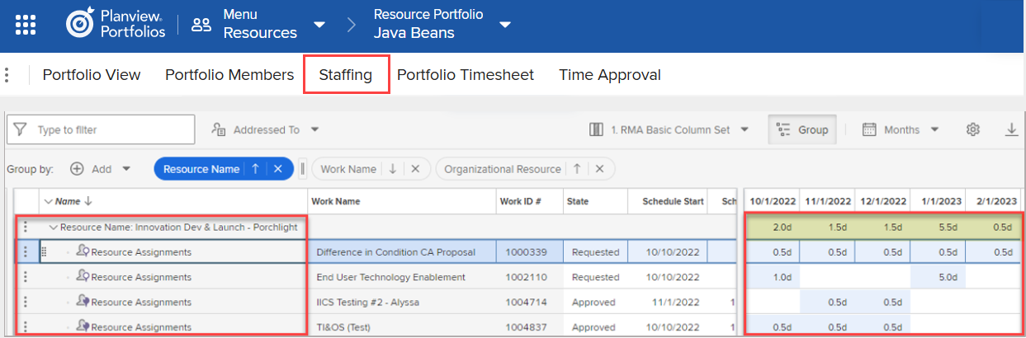
Don’t Forget:
- If you make any changes to the reserve hours, you need to communicate what you have done to the relevant Work Manager.
- Communications should take place between the original and new team’s Agile Leader to ensure the reserves hours for work items are adjusted appropriately from both team views.

Manage Team Work in Jira
Objectives
- Review issues to ensure they reflect the correct status; this will make sure that actual hours are being created correctly.
- Review issue assignments to ensure that the correct person is assigned based on who is doing the most work on the card.

What You Need to Know
If the issues statuses and assignments are not managed appropriately, it will cause the actuals created via agile costing to be under or over inflated.

Manage Issue Statuses and Assignments
Keep the following in mind when managing issue statuses and assignments:

Important:
- Statuses considered “In Progress” are the following: In Analysis, In Testing, & In Development
- Issue types that are included in Agile Costing are Bug, Task, Tech Debt, Risk, and Story

- Issues that spend any part of the day in an “In Progress” status are included in agile costing. It is critical that you do not move a card to an “In Progress” status unless you know you will be working on the card. If the card is on hold, you must change the status to “On Hold”, or it will continue to charge.
- Issues assigned, in progress, and linked to a Planview Portfolios epic at any time during the day will be counted towards agile costing.
- Issues without an epic are ignored. Click here to access a template filter for finding In Progress issues with no Epic Link.
- Issues without an assignee are ignored. Click here to access a template filter for finding In Progress issues with no Assignee.
- Issues not updated for more than 15 calendar days will not be included in agile costing. Click here to access a template filter for finding In Progress issues not updated in > 15 days.
- Ensure your team members are not assigned to issues from previous teams. Click here to access a template filter for finding issues assigned to a set of users.

